The project consists of three main components that interact as follows:

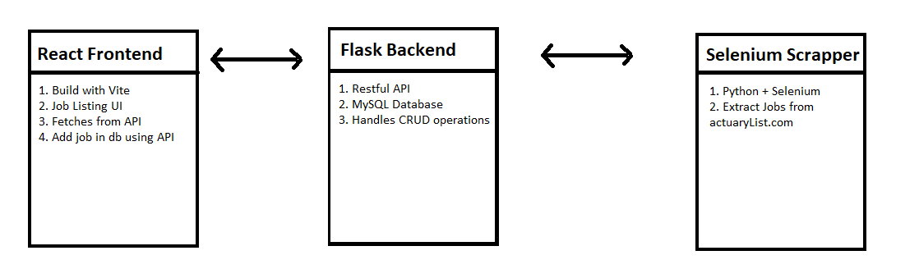

**Design Rationale:**

1. Flask + SQLAlchemy: Simple, lightweight, and ideal for a testable backend.
2. React (Vite): Fast build and hot-reload for frontend development.
3. Selenium: Reliable for dynamic page scraping, especially when content loads via JavaScript.
4. Loose Coupling: Each layer (frontend, backend, scraper) is independent and can run separately, improving modularity and scalability.